

Hamdard University

Department of Computer Science (FEST)

***Final Year Project  
Proposal***

Complaint Management system for Housing Society

Abdul Moiz Hussain / BSCS-F14-0128

Muhammad Areeb Vohra / BSCS-F14-0112

Muhammad Taha Amin / BSCS-F14-0117

**Supervision from:**

Sir Adnan Ahmed Siddiqui

*(Assistant Professor)*

Table of Contents

1.0- Introduction 3

1.1- Problem Statement 3

1.2 Motivation 3

1.3 FYP Objectives 3

1.4 Literature Review 3

2.0 Project Scope 4

3.0 Methodology 4

3.1 Project Approach 4

3.2 Team Role & responsibilities (RACI matrix) 4

3.3 Requirement Development 5

3.4 Architect / Design 5

3.5 Development / Construction 5

4.0 Project Planning 5

4.1 Gantt Chart 5

4.2 Mention following *milestones* in your Plan 5

5.0 Project Requirements 6

5.1 Software tools requirements 6

5.2 Hardware requirements 6

6.0 Budget/Costing 7

6.1 Mention the budgeting cost of each item - required for the this project 7

6.2 Total Budgeted Cost - of the Project 7

7.0 Project Deliverables 7

8.0 Reference 7

Appendix 7

# 1.0- Introduction

## 1.1- Problem Statement

In housing societies, if there is a problem regarding any household issues like electricity, plumbing, gas leakage, carpentry, fumigation or any other problems, a person himself has to go and bring a repair man, which takes a lot of time and efforts.

## 1.2 Motivation

We introduce this application which will integrate society’s every problem on a platform, and the solution will be one click away to be solved. So, that less efforts will be required from the person for their problems to be solved in a smart way.

## 1.3 FYP Objectives

* The main objective of this project is to develop a web and application based software that is used to inform about the problem of the person is having, concerning any household glitches like leaking of gas, water seepage, electricity issues, plumber required for wrecked furniture etc.
* The salient objective to develop a mobile application is for the reduction of complexity in the system and essentially to save people’s time.
* Android is the most popular platform in the world of innovations, It’s usage is not

## 1.4 Literature Review

Study of Implementation of Society Management System

The concept of this paper is that to keep the people of a society up to date with their daily activities, by notifying the activities on the application. So majority will go through with every problem or issue, along with, in the societies where people don’t interact with each other much, will be able to strengthen their neighborhood. [1]

UBIQUITOUS SMART HOME SYSTEM USING ANDROID APPLICATION

The paper defines an android based application which uses an Arduino as a server to control the appliances of a home.  
This can help us in using the methodology to control not any appliances but the complaints of the society, by using internet server/domain instead of Arduino, as a connecting medium. [2]

Implementation of Facility Maintenance Management System using Smart Phones

This paper conveys the message that the use of smart phones is increasing gradually and the whole world is in the palm of our hands through high speed internet and cellular internet connectivity, due to which the use of web based applications on personal computer is decreasing. This paper proposes an integrated android based mobile application and a web based system that facilitates maintenance management in apartment buildings that saves unnecessary man power that can be used in other aspects.

The methodology of creating an integrated mobile application and web based system is useful to consult the idea of our project.

# 2.0 Project Scope

Our Project will include a Website and Android app through which user can submit a request for services we have provided which includes electrician for any kind of electronic repairs, carpenter for any furniture damage, fire brigade, ambulance, doctor and plumber for any plumbing issues.

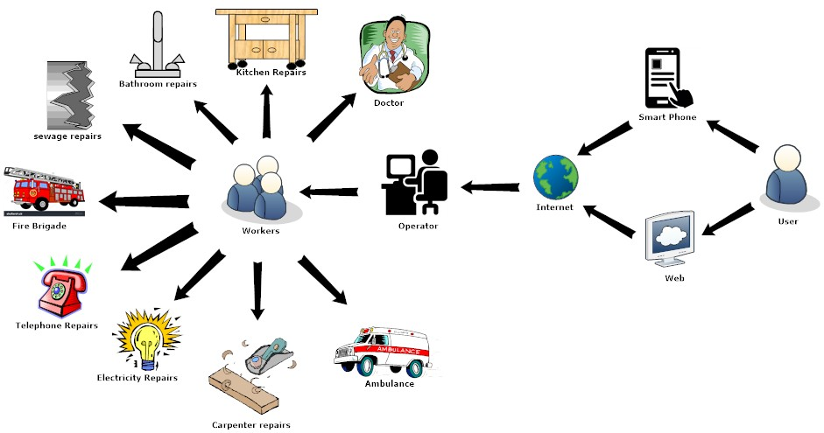

# 

# 3.0 Methodology

## 3.1 Project Approach

Agile approach will be used.

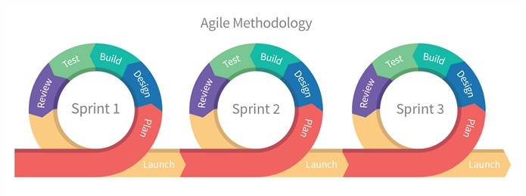

## 3.2 Team Role & responsibilities (RACI matrix)

**R**esponsibility, **A**ccountability, **C**onsultant, **I**nformed.

|  |  |  |  |
| --- | --- | --- | --- |
|  | **Taha Amin** | **Areeb Vohra** | **Abdul Moiz** |
| **Design** | R | I,C | A |
| **Analysis** | R,I | R | A,C |
| **Development** | C,I | R,A | R,C |
| **Testing** | A,I | R | A,C |

## 3.3 Requirement Development

* Elicitation of requirements
* Analysis of requirements
* Requirement Validation

## 3.4 Architect / Design

Big picture (system)

Entity Relation Diagram

Any other diagram you have studied

## 3.5 Development / Construction

* We will work on android studio using Java programming language for the development of smart application.
* Web based work will be developed with use of HTML, CSS, PHP and which will be connected to MySQL for back end receiver and storage of data.

# 4.0 Project Planning

4.1 Gantt Chart

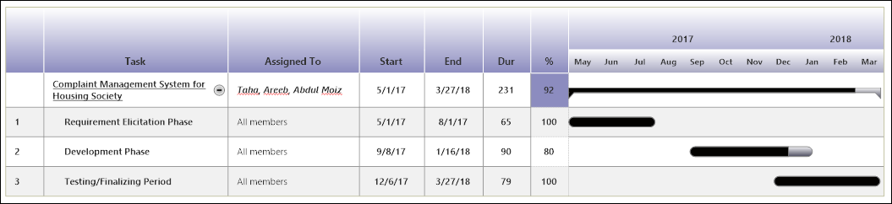

## 4.2 Mention following *milestones* in your Plan

***Progress Evaluation***  
In progress (First) evaluation of the project, we will show our near completing project.

***Final Report***  
In final (Second) evaluation of the project we will show our completed project with all the proper functionalities of applications.  
Insha Allah.

# 5.0 Project Requirements

## 5.1 Software tools requirements

Android Studio

Word-Press

Dream-Viewer

MySQL

MS-Office

## 5.2 Hardware requirements

* Android Phone *– for application testing.*
* Desktop/Laptop Quad Core Processing Unit *– for Web interface development*
* Internet (3G/4G) Device *– for testing the connection between mediums.*

# 6.0 Budget/Costing

## 6.1 Mention the budgeting cost of each item - required for the this project

* Android Mobile (7000-8000 PKR)
* Desktop Quad Core Processing Unit)(approx. 10,000 PKR)
* Internet (3G/4G) Device (approx. 4000PKR)
* Domain (2500 PKR/per annum)

## 6.2 Total Budgeted Cost - of the Project

Approximately 24,000 PKR.

# 

# 7.0 Project Deliverables

Mention the ***project deliverables*** such as

* Requirements documentation
* Design Documents (ERD, design etc )
* Running software application
* Software code in CD

# 8.0 Reference

1. Gavhane, S., et al., *Study of Implementation of Society Management System.* International Journal of Computer Applications, 2015. **132**(1): p. 34-36.

2. Kumar, S., *Ubiquitous smart home system using android application.* arXiv preprint arXiv:1402.2114, 2014.